Privacy Act Australia Compliance for Log360
Strengthen data protection and meet Privacy Act Australia compliance with Log360.
Region: Australia | Type: Data Privacy, Government/Public Sector | Category: Compliance | Pricing: Free

Overview
The Privacy Act Australia compliance extension in Log360 helps organizations meet the Privacy Act 1988 (Cth), Australia's principal privacy legislation issued by the Commonwealth Parliament and enforced by the OAIC covering government agencies and private organizations by providing centralized log management, access monitoring, file activity auditing, and threat detection. The platform supports Privacy Act Australia requirements for transparent PI management, lawful collection, authorized use and disclosure, data quality assurance, security safeguards, cross-border disclosure controls, and individual access rights.
For Open and Transparent Management of Personal Information (APP 1), Log360 tracks policy changes, GPO modifications, system events, and Entra ID policy management to verify that governance controls are consistently enforced. To address Collection of Personal Information (APP 3-4), the platform records all user logon activities across Active Directory, Windows, and Unix environments, providing visibility into who accesses systems where personal information is collected and processed. The extension also supports Authorized Use and Disclosure Controls (APP 6-7) by providing capabilities that monitors user account changes, group membership updates, and permission modifications to detect unauthorized access attempts or privilege escalations affecting personal information.

Key Features
- Security of Personal Information (APP 11): Log360 detects threats via antivirus integration, monitors file changes, audits removable media, and tracks registry modifications to enforce personal data security safeguards.
- Cross-Border Disclosure of Personal Information (APP 8): Log360 monitors network device policies and firewall activity to track and audit cross-border data flows for compliance with overseas disclosure requirements.
- Open and Transparent Management of Personal Information (APP 1): Log360 tracks policy changes, GPO modifications, system events, and Entra ID policy management to verify that governance controls are consistently enforced.
- Collection of Personal Information (APP 3-4): Log360 records all user logon activities across Active Directory, Windows, and Unix environments, providing visibility into who accesses systems where personal information is collected and processed.

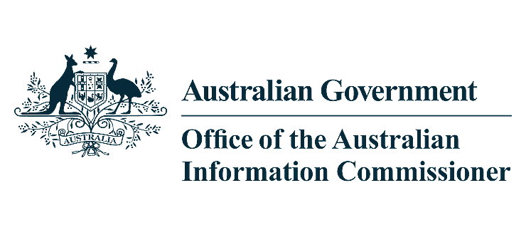
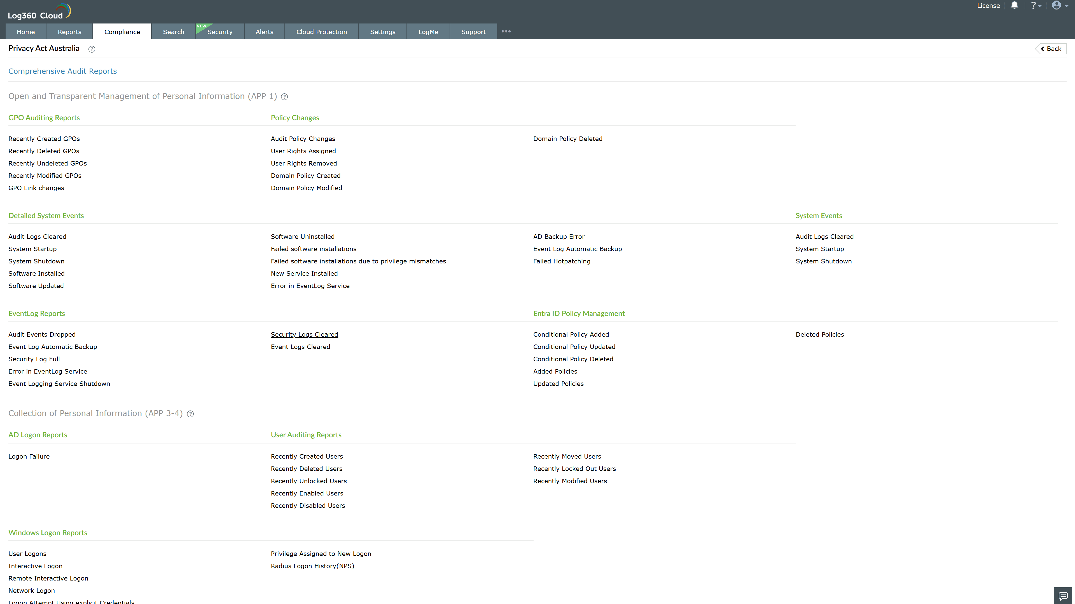
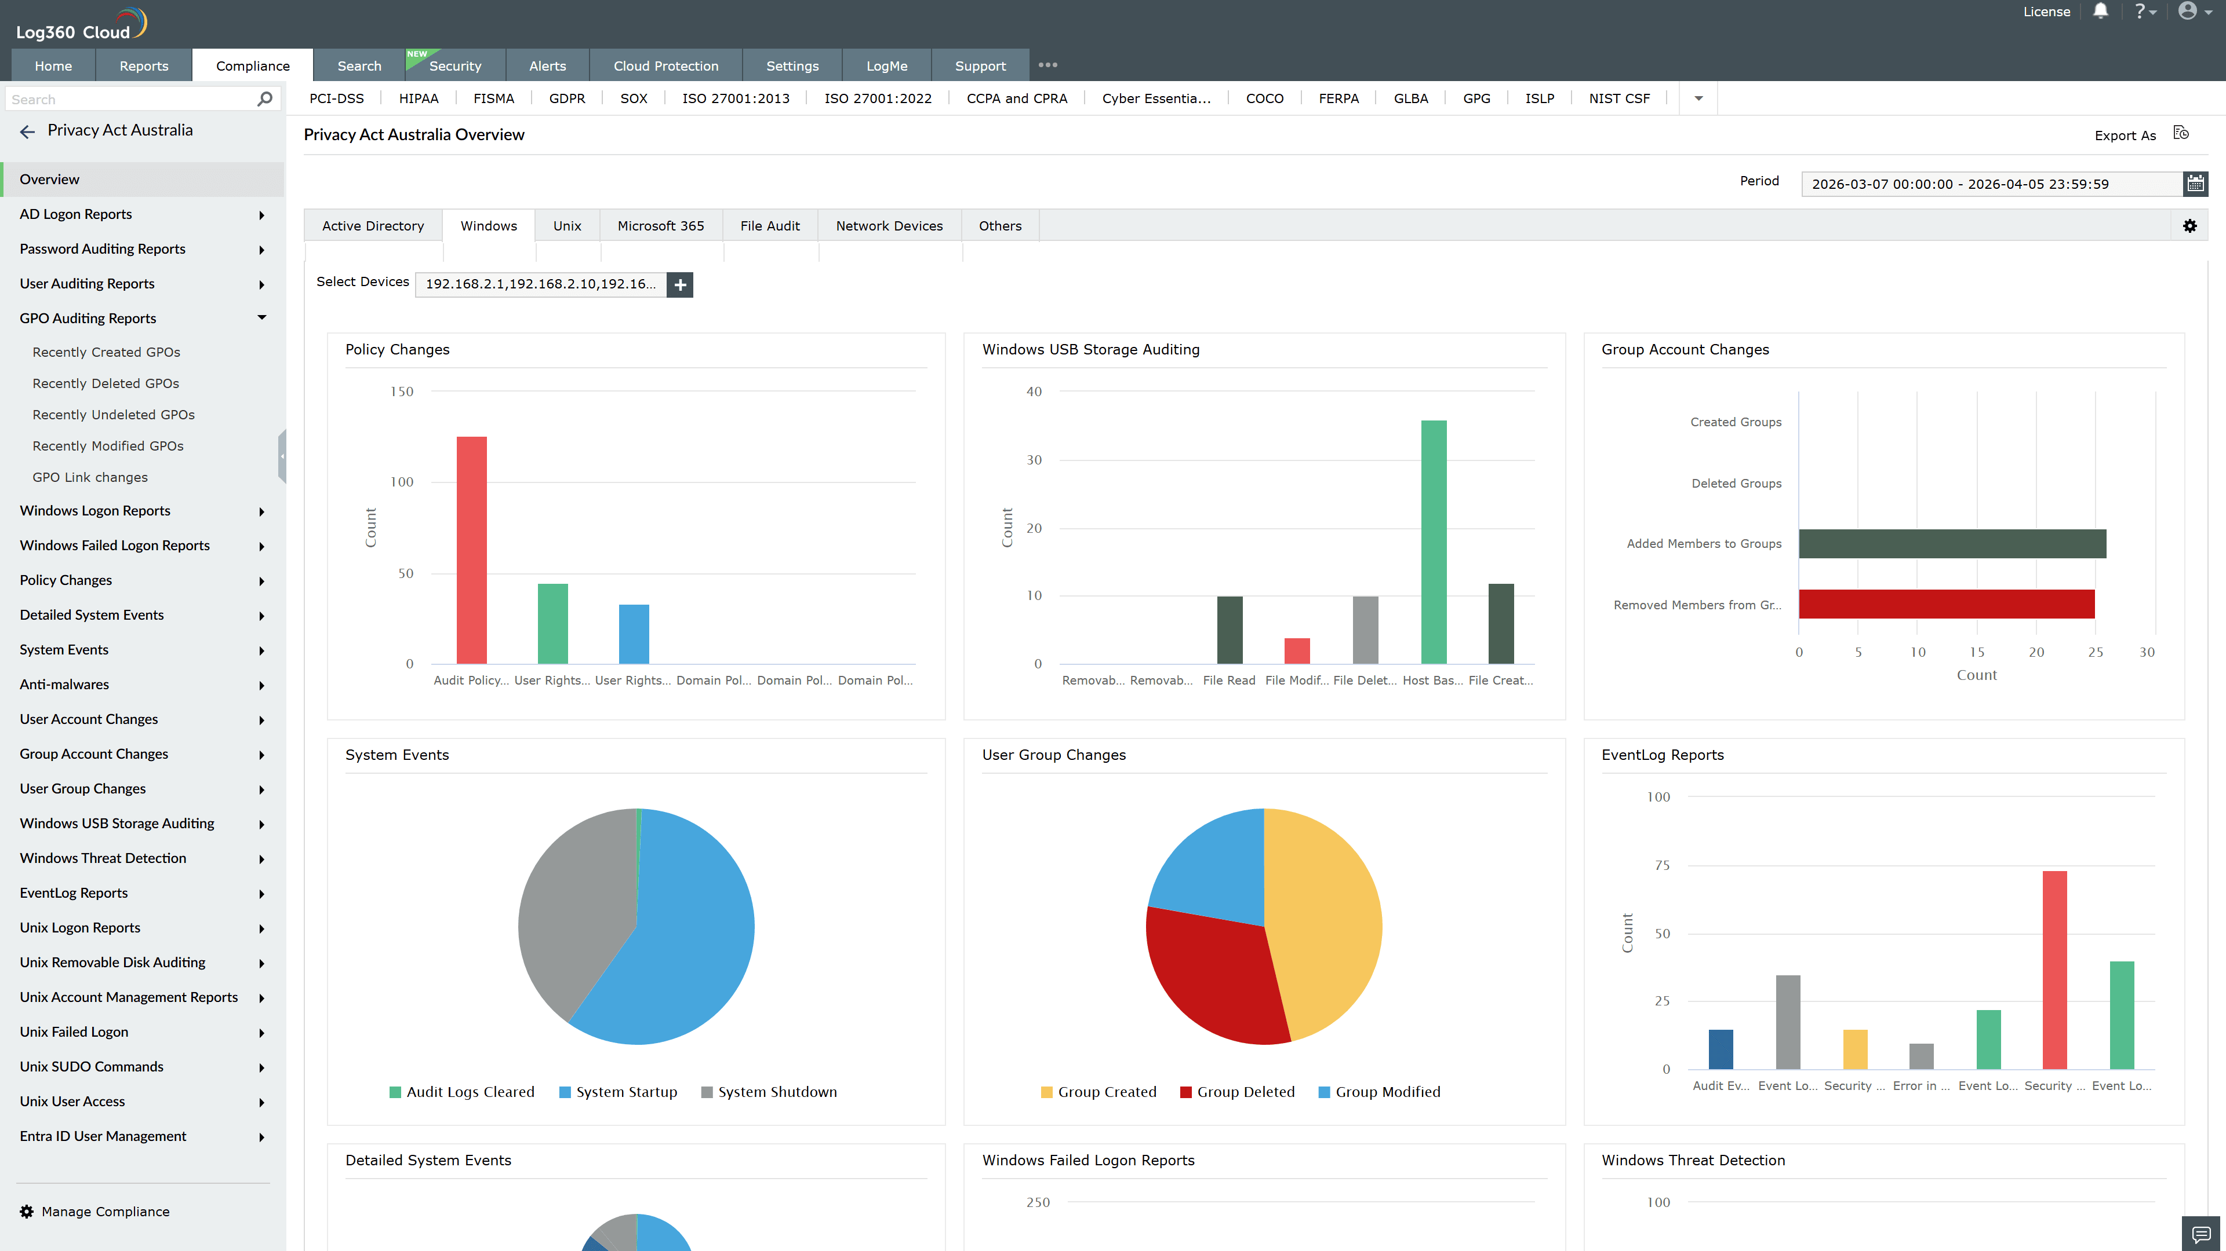
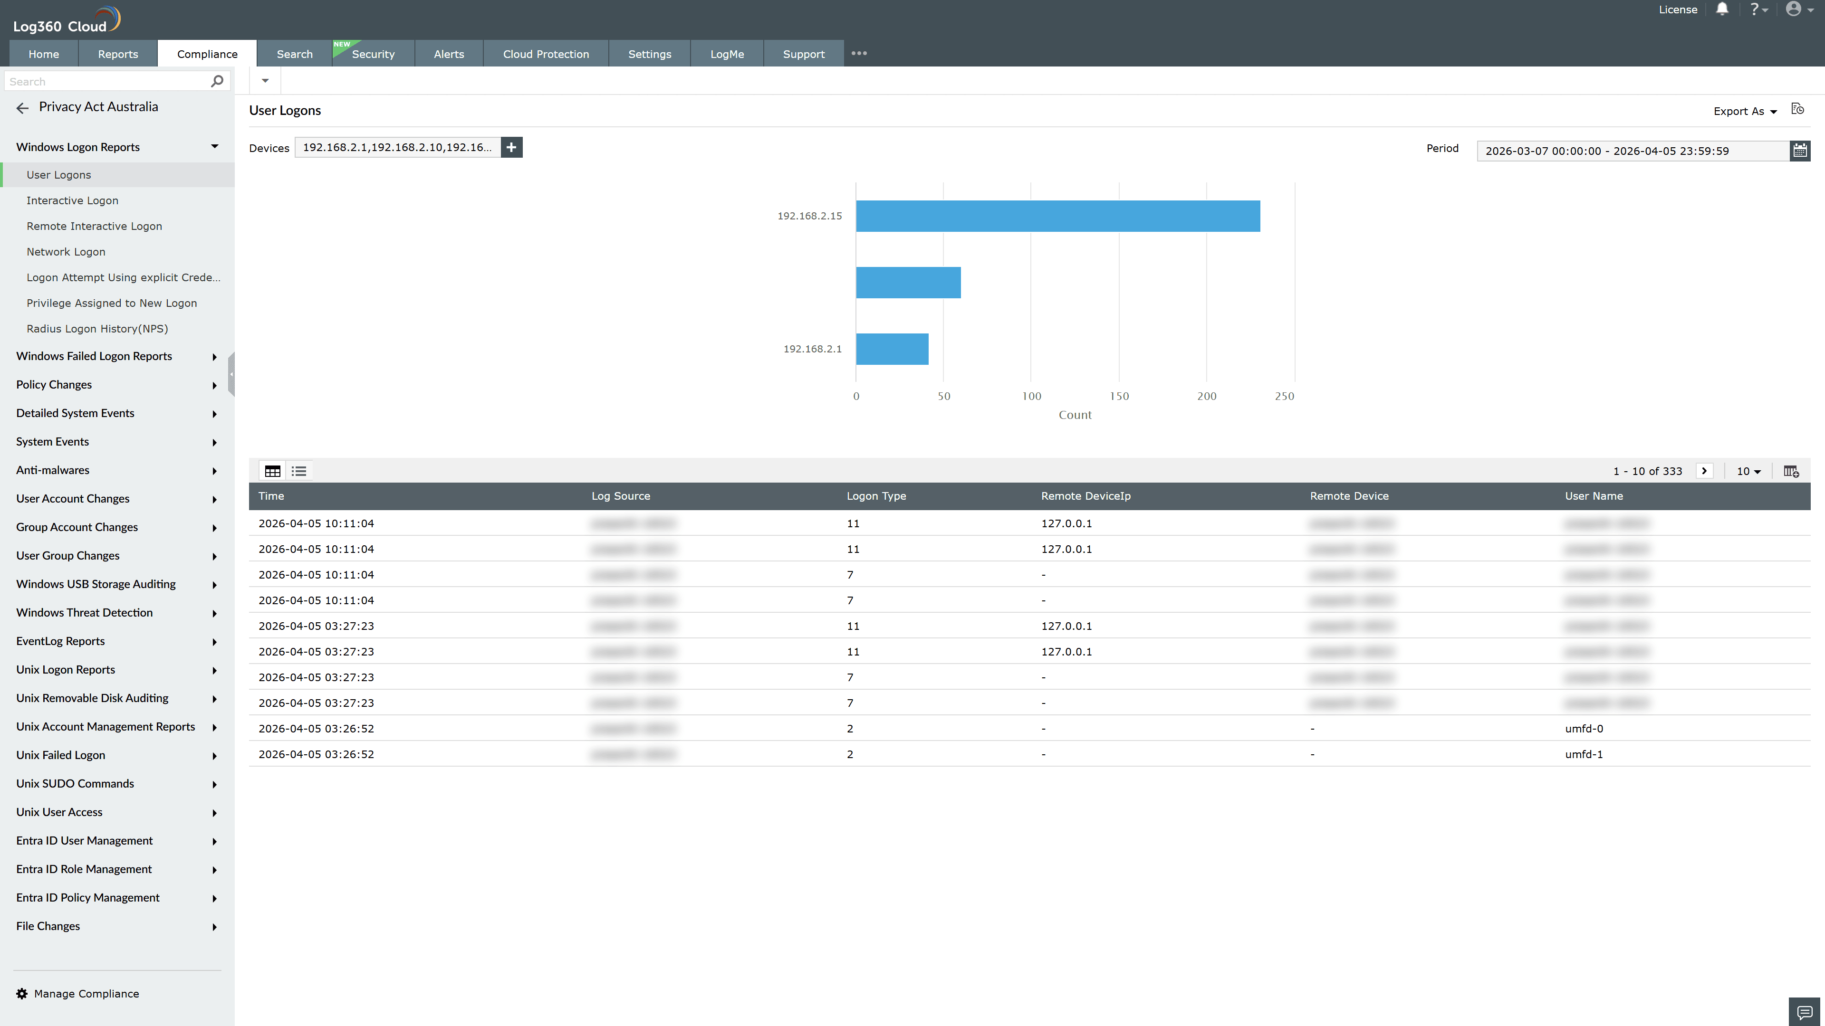
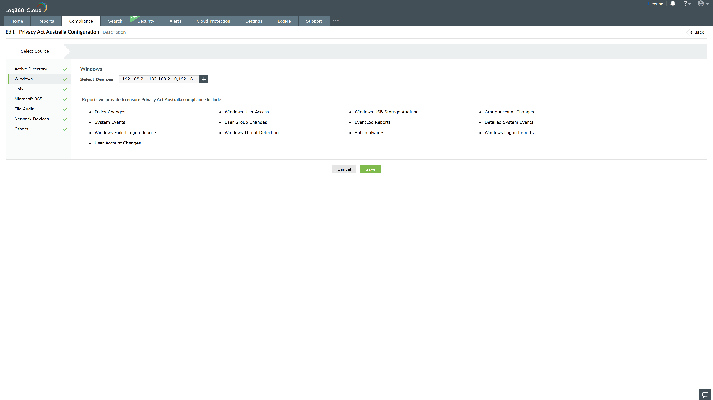
Valid Submission : Yes
Supported Editions : Free, Basic, Standard, Professional, MSSP
Help Document : https://www.manageengine.com/log-management/help/integrations/compliance-extensions.html
Help Video : Not provided
Tags : Log360, Compliance, Privacy monitoring, Data privacy, Regulatory compliance
Supported DCs : US, IN, JP, CA, AU, UK and EU
Privacy Policy:
Terms of Service:
Release Notes:
Predefined reports for the Privacy Act Australia.

